Name: Abdul Wasaey Qasim Class: 9-B Date: 19th April Sunday 2020

Overall mark

Investigating fatigue in arm muscles

Question: ………………………………………………………………

Your prediction: I Think the less time we get to rest the less lifts we get in the time

5. Are there hazards with the experiment and how will you minimize them?

|  |  |  |  |
| --- | --- | --- | --- |
| What is the hazard? |  | How could it be  dangerous? | How will you reduce the risk? |
| The arm being tired |  | I could drop the ball because I would be tired | Try and throw the ball away if it comes to the point that I would need to drop it |
|  |  |  |  |
|  |  |  |  |
|  |  |  |  |
|  |  |  |  |
|  |  |  |  |
|  |  |  |  |

**Section 2 - Results**

6. Record your results in a table.

|  |  |  |  |
| --- | --- | --- | --- |
| **Names:**  **(Place Holders)** | **Test 1**  **(60 secs)** | **Test 2**  **(30 secs)** | **Test 3**  **(0 secs)** |
|  |  |  |  |
| **Me**  **My father**  **My cousin** | **63**  **61**  **62** | **67**  **62**  **44** | **68**  **65**  **42** |
|  |  |  |  |
|  |  |  |  |
|  |  |  |  |
|  |  |  |  |
|  |  |  |  |
|  |  |  |  |
|  |  |  |  |

**Section 1 - Planning**

1. What will be the independent variable? (What will you change?)

The time we get to rest

2. What will be the dependent variable? (What will you measure?)

The amount of repetitions

3. What are the control variables?

(What will you keep the same to make it a fair test?)

Using the same object

4. Describe how you will carry out the experiment.

(Name the key equipment you will use and talk about how

you will measure your results)

I will use the object and lift it as many times as possible for 1 minute then rest, decreasing the rest each time.

5. Draw a graph of your results.

Remember to label your axes and include the correct units.

**Section 3- Conclusions**

6. Can you compare………………………………………...?

As the test went on, me and my father’s repetitions increased likely due to the fact that our arms warmed up. My cousin showed signs of fatigue because the number of repetitions he did decreased in the test.

7. Can you explain your results?

The results showed to things, that depending on the strength of the person . Because some people can be getting warmed up while as others get tired before getting warmed up

8. How could the experiment be improved to get better or more reliable results?

I think we should repeat the experiment more time in order to get fatigue in the arms of the others.

**Investigating fatigue in arm muscles**

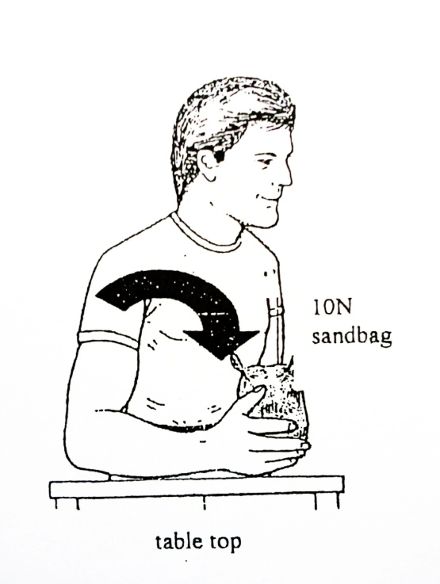**Procedure:**

1. Place your elbow and forearm of the right arm (or left if left-handed) on the table as shown. Place the around a 1kg object in the hand and grasp it firmly.
2. Press start on a stop-clock.
3. Lift the object from the bench to the shoulder as many times as possible in 60 seconds. Record the number of lifts.
4. Leave the stop-clock running and allow yourself to rest for 60 seconds.
5. Repeat the object lifts for the next 60 seconds. Record the number of lifts.
6. Leave the stop-clock running and allow yourself to rest for 30 seconds.
7. Repeat the object lifts for the next 60 seconds. Record the number of lifts.
8. Leave the stop-clock running and immediately repeat the object lifts for the next 60 seconds. Record the number of lifts.
9. Collect results from 2 more people in a table

**Results**

(How will you record your results? What is the best way to display your data? This can be done on a separate page/graph paper)

**Tasks and questions:**

1. Plot this data as a graph.
2. Describe the trends show in the graph. What effect did rest periods have on lifting performance?
3. Explain what may have caused these trends by considering any substances that may have been used up in the muscle, and the process that was using them.
4. Describe the physical observations that the subject made during the investigation.
5. Explain what may have caused these symptoms by considering another substance that may have been produced in the muscle and the process that was producing it.